Class Newsletter April 3, 2015

Dear Parents and Families,

On Wednesday we went to the Flynn to see the theatrical performance of the book, Harold and the Purple Crayon. The class enjoyed seeing how the theater group performed different parts of the book. For instance we predicted how they would act out Harold climbing the mountain and then falling off the other side. Ask your child to fill you in on how they did it!

Here’s a summary of what we learned this week:

Reading – Fluency and Punctuation - Our learning target is, I can read smoothly and expressively like talking. This week students evaluated and sharpened their fluency and expression skills by video recording each other reading. Small groups were given the same book that each student had to read and reread before doing their very best fluent, expressive reading for the camera. They listened to each other and provided constructive feedback on one another’s reading. These videos were then turned into QR codes, which we’ll hand down to the kindergarten class. The class learned that QR codes are used for storing URLs or other information for reading by the camera on a smartphone or tablet. The use of the codes allows anyone with these devices to access information from anywhere. The codes we created can now be accessed by the kindergartners in their very own classroom. Our work will help the kindergarteners build their own reading skills by listening to first grade read alouds that are smooth and fun to listen to.

Integrated Studies- Science: Light Unit- This week the class answered these two focus questions; How can the size of a shadow be changed? And What do we need to be able to see something? In the shadow size investigation students worked together to test what happens to the size of a shadow puppet when it is moved closer to a flashlight and when it is moved further away. From experimentation the class was able to conclude that their puppet’s shadow increased in size when closer to the light and decreased in size when further away. This we discovered was because the puppet blocked more light when it was closer.

In our second investigation students experimented with seeing an apple in a room with various amounts of light; full light, some light, and absolutely no light. Students worked to understand that objects can only be seen if light is available to illuminate it.

Math – Our Learning Target is, I can use the ‘take from ten’ strategy to help me solve problems with three numbers. We continued to practice the ‘take from ten’ strategy by subtracting 9, 8, and 7 from teen numbers as they decomposed the larger subtrahend into ten and some ones.
Students solved problems such as, “Cameron had 13 markers in her bag. Eight markers fell out of the bag. How many markers does Cameron have now?” as follows:
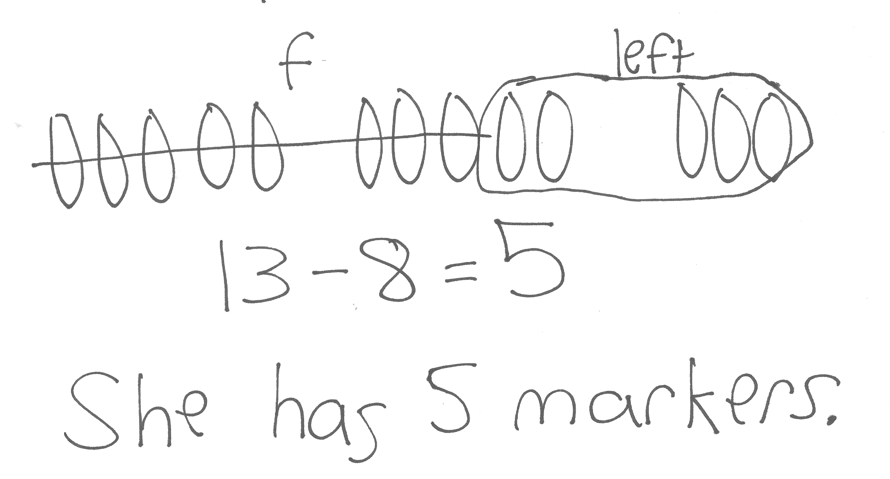Students learned to represent their thinking through concrete, pictorial, and abstract representation. We learned that the ‘take from ten’ strategy is a more efficient way to solve problems and leads to mental math. By using 7, 8, and 9 they were able to generalize this strategy to several numbers. You can support this learning at home by practicing this strategy, subtracting 9, 8, or 7 from teen numbers and have your child record their thinking.

Word Work – Our current Fundations unit is: Compound words, two syllable words. Example words include: backpack, cupcake, basketball, suntan, bathtub, public, picnic, frantic
Sight words we studied and quizzed this week: line, right, too, mean, old
Next week’s sight words: friend, same, tell, boy, girl
You can find all our sight words to date, as well as what’s coming up next at
http://mrsgalushasfirstgrade.weebly.com/word-work.html

Some other logistics:

- Our next FIELD TRIP is on April 16th to Shelburne Farms. More information will be coming home as the date gets closer.
- SCHOOL PLAY, “The Great Squirrel Uprising” is on Tuesday, April 14th at 6:30pm.
- SPRING RECESS, No School April 20th to April 24th.

Please feel free to contact me anytime, and please check out our website!

Sincerely,
Jeannine E. Galusha
jgalusha@bsdvt.org

www.mrsgalushasfirstgrade.weebly.com www.twitter.com/galusha1stgrade

